Similar Questions

1a.
We assume in this task that a projection (like in SQL) does not remove duplicates. Give an example to show that projection cannot be pushed below intersection.
For example, find relations RRR and SSS such that:
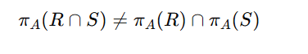

1b.
We assume in this task that a projection (like in SQL) does not remove duplicates. Demonstrate with an example that projection cannot be pushed below the difference operation.
For example, provide relations RRR and SSS such that:
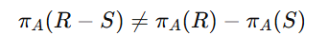

1c.
We assume in this task that a projection (like in SQL) does not remove duplicates. Show that projection cannot be pushed below a Cartesian product.
For example, find relations R and S such that:

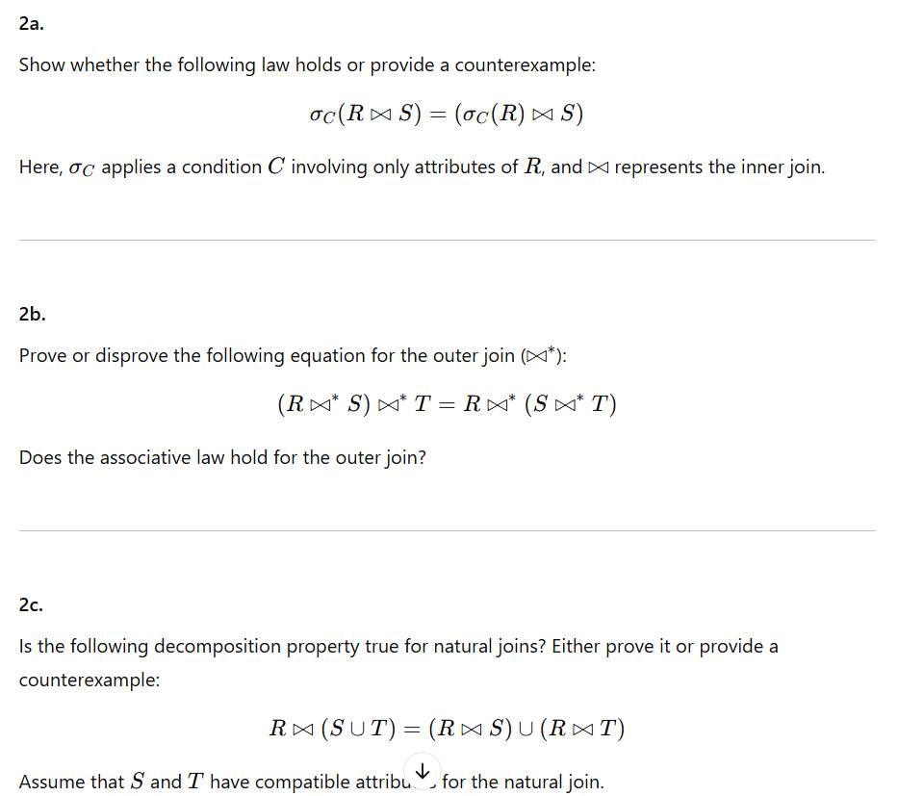

2a:
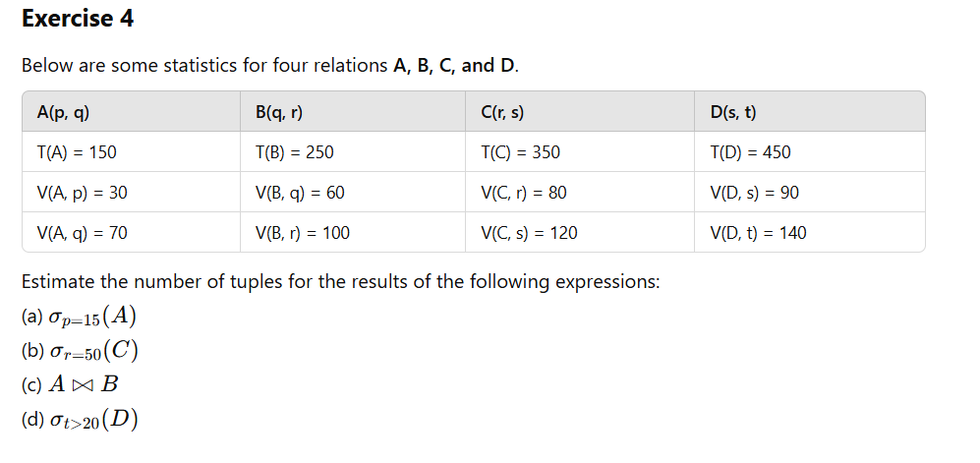
2b:
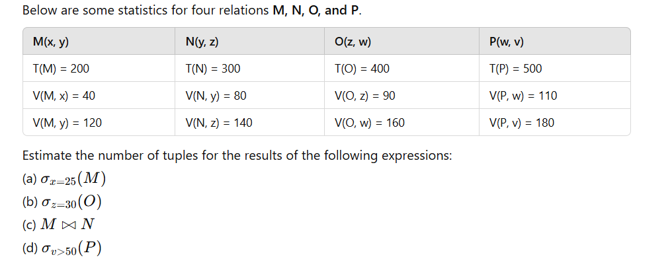
2c:
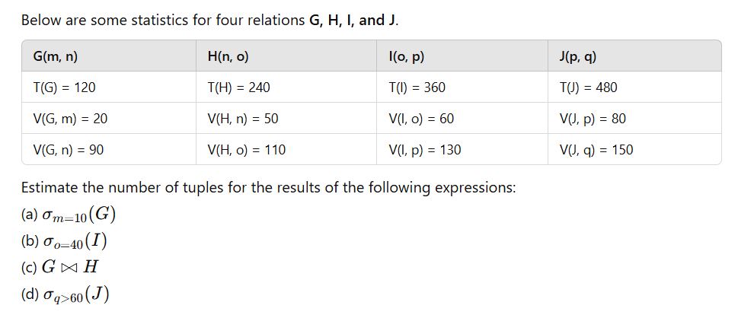

Exercise 2a (With Solutions)
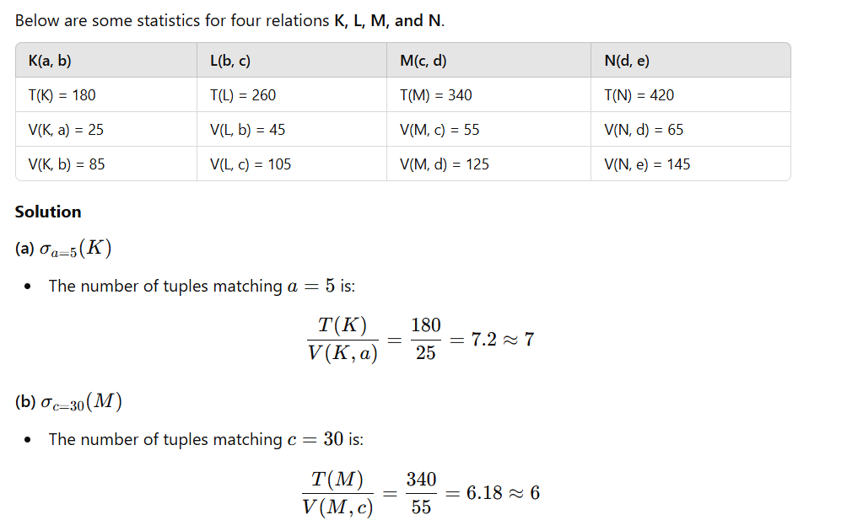
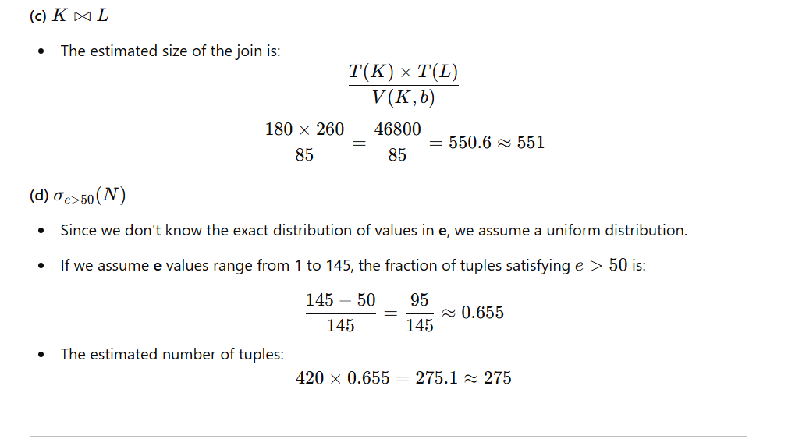

Exercise 2b (With Solutions)
Below are some statistics for four relations P, Q, R, and S.
